CS 305 Project One

Document Revision History

Version | Date | Author | Comments
1.0 | 25 Jan 2026 | Talon Douglas | Initial Submission

Client



Developer
Talon Douglas

1. Interpreting Client Needs
When it comes to developing financial plans for customers, secure communications are vital for ensuring sensitive customer data isn’t leaked. Artemis Financial is likely dealing with very large portfolios, some potentially worth millions of dollars, especially for the retirement accounts. This makes them a reasonable target for attacks, especially with the aim of obtaining access to the finances. Giving a bad actor access to this data, such as monthly statements, can lead to large financial losses for their customers.
It’s very possible that international transactions may come into play. For example, a European resident may decide to invest in U.S. stock markets. Based on the information provided, we aren’t entirely sure where this company is based out of, so we’ll analyze regulations from a U.S. federal perspective. In the U.S., there are multiple laws and regulations when it comes to financial consulting. The Financial Modernization Act of 1999 establishes requirements for privacy of consumer finances and protection of costumer information (Federal Trade Commission [FTC], n.d.); this means proper encryption for sensitive-data and thorough protection from cyber-attack attempts. However, even if the company is operating within the U.S., they may also be subject to foreign laws. If we look back at our example of a European resident investing in U.S. stock markets, their data is protected under the General Data Protection Regulation, or GDPR. This regulation protects data of EU residents, even if the data is being handled or processed outside of the EU (General Data Protection Regulation, 2016). Some external threats would include any bad actor attempting to gain access to large portfolios. Additionally, some bad actors may attempt to target high-profile, wealthy customers in particular.
Modernization requirements, like open-source libraries, should always be considered, as they can save a lot of time in the development of basic common functions. However, they also come with their own security risks if not properly implemented (Nadagoud, 2024). Evolving web application technologies should also be considered as every update to a library, browser, web hosting server, and more can introduce security risks. Another modernization requirement may the cloud. While it can provide many benefits, it can also lead to data breaches if your settings are misconfigured (Chaudhary, 2023).

2. Areas of Security
There are several areas of security that should be considered during the vulnerability assessment. Firstly, input validation. Because the software is going to be dealing with deposits, users may be able to enter in numbers that the software shouldn’t accept. Additionally, when users log in, the login verification should be designed to avoid accepting raw inputs that may lead to injection (Manico & Detlefsen, 2014). Secondly, APIs. Artemis Financial has an API, and if not properly protected, users can query the API a large amount of times in a short timeframe leading to a DoS or exploit them to bypass access controls (Manico & Detlefsen, 2014; OWASP, 2023).
Next, cryptography. Encrypting data at rest and in transit is critical when handling finances, and that need is emphasized by both regulations and the chance of attack given the potentially large portfolios being handled. Lastly, encapsulation. Encapsulation is the concept of bundling data and methods to hide internal data and protect it from unauthorized access (Twingate, 2024). Encapsulation vulnerabilities provide bad actors insight into how the software works, allowing them to develop and fine-tune attacks to gain critical data (Veracode, n.d.). This also highlights why secure error handling is critical to address as well. Part of an encapsulation attack is initiating non-typical requests in order to view the resulting error code. Sometimes, these errors can give detailed information about the types of systems a software is being run on (Veracode, n.d.).

3. Manual Review
- In customer.java, the deposit method doesn’t verify the input to ensure the deposit isn’t a negative amount (in other words, a withdrawal).
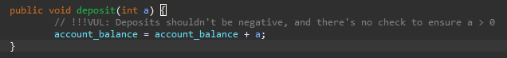

- In DocData.java, the read_document method has a try-catch statement where the catch portion uses the e.printStackTrace() method. This method is meant to help developers and can provide detailed information in the log that an end user could use to initiate an encapsulation attack (Educative, n.d.; Veracode, n.d.).
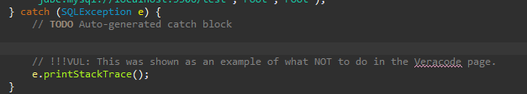

- In CRUDController.java, the /read endpoint can accept any value for business_name¸ which may potentially open this endpoint up for an injection attack since there’s no input verification.
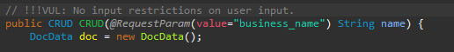

- There are also no access controls for the /read endpoint, which means any end-user could read any businesses information.
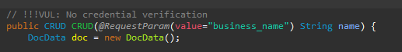

- Similarly to before, the /greeting endpoint has no input verification, potentially opening it up to an injection attack.
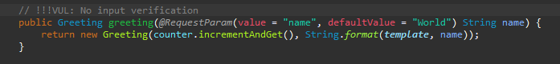

- Additionally, the argument for defaultValue in the greeting method of GreetingController.java is not properly formatted, so the URL localhost:8080/greeting gives a status 500. Because of this and the fact that status 500 errors take more resources than a 404 for example, this poor error handling opens the application up DoS attack if an attacker sends enough requests to this URL.
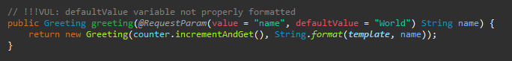
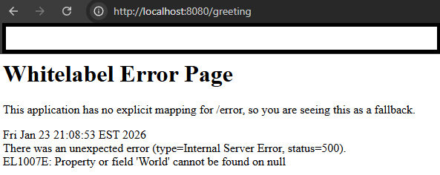

- In DocData.java, the read_document method uses the DriverManager.getConnection() method with 3 arguments: a URL, a username, and a password; however, the username and password are hardcoded as “root”. If this were to be in production, end users could use the username and password “root”, which is likely an admin username/password.

4. Static Testing
Through the static testing, there were around 150 CVEs found with severities ranging from medium to critical. These CVEs were related to several dependencies within the project. Below are the dependencies that came up with vulnerabilities. I’ve also included the specific CVEs with CISA known exploited vulnerabilities and prioritized mitigating these, as recommended by the Cybersecurity & Infrastructure Security Agency (2021).

CRITICAL Severity:
- Tomcat-embed-websocket-9.0.30.jar (48 CVEs)
  - CVE-2020-1938
    - There is an issue when using Apache JServe Protocol where Tomcat trusts it more than similar HTTP connections. This allows attackers to even take over the content of a web application. Mitigation is only required if an AJP port is accessible to an untrusted user, however it is recommended that the connector be disabled if it isn’t required (National Vulnerability Database [NVD], 2025).
  - CVE-2025-24813
    - If a list of conditions were true, attackers would be able to view sensitive files and potentially inject content into the files. Separately, if another list of conditions were true, an attacker could potentially perform remote code execution. Users are recommended to upgrade to versions: 11.0.3, 10.1.35, or 9.0.99 (NVD, 2025).
  - CVE-2023-44487
    - HTTP/2 protocol allows DoS due to the ability to reset many streams via request cancellation (NVD, 2025).
- Tomcat-embed-core-9.0.30.jar (47 CVEs)
  - CVE-2020-1938 (See above)
  - CVE-2025-24813 (See above)
  - CVE-2023-44487 (See above)
- Spring-web-5.2.3.RELEASE.jar (13 CVEs)
  - CVE-2022-22965
    - This CVE seems to only affect applications running on JDK 9+, but when ran on tomcat as a WAR deployment, it can be vulnerable to remote code execution. If the application is deployed as a Spring Boot executable, this specific CVE does not seem relevant, but the exploit itself is more general and may still be exploitable (NVD, 2025).
- Spring-core-5.2.3.RELEASE.jar (12 CVEs)
  - CVE-2022-22965 (See above)
- Snakeyaml-1.25.jar (8 CVEs)
- Spring-boot-2.2.4.RELEASE.jar (3 CVEs)

HIGH Severity:
- Jackson-databind-2.10.2.jar (6 CVEs)
- Bcprov-jdk15on-1.46.jar (4 CVEs)
- Logback-core-1.2.3.jar (2 CVEs)

MEDIUM Severity:
- Hibernate-validator-6.0.18.Final.jar (3 CVEs)
- Log4j-api-2.12.1.jar (2 CVEs)

5. Mitigation Plan
The best approach to mitigating the found vulnerabilities seems to be largely just updating each dependency to a newer version. However, there is always the potential that updating a dependency creates issues with compatibility. Therefore, some CVEs have additional, short-term recommendations to mitigate the issue.
Tomcat’s CVE-2023-44487 suggests lowering the limit of the maximum number of concurrent HTTP/2 streams and reconfiguring the number of requests per TCP (Shetty, 2023). Additionally, Tomcat’s CVE-2020-1938 states that further mitigation is only required if you are unable to disable the AJP connector due to application requirements. Spring web’s CVE-2022-22965 recommends not deploying the application as a WAR deployment until you’re able to update to 5.2.20 or higher (Spring, 2022); however, because the underlying vulnerability seems more general and may still be exploited via different methods under older versions, updating the dependency is the most recommended option (NVD, 2025).
To summarize, while steps can be taken to mitigate many of these vulnerabilities, updating to a patched version is always recommended.

References
Chaudhary, A. (2023, August 14). Managing Cloud Misconfiguration Risks. Cloud Security Alliance. https://cloudsecurityalliance.org/blog/2023/08/14/managing-cloud-misconfigurations-risks
Cybersecurity & Infrastructure Security Agency. (2021, November 3). BOD 22-01: Reducing the Significant Risk of Known Exploited Vulnerabilities. https://www.cisa.gov/news-events/directives/bod-22-01-reducing-significant-risk-known-exploited-vulnerabilities
Educative. (n.d.). What is the printStackTrace() Method in Java?. https://www.educative.io/answers/what-is-the-printstacktrace-method-in-java
Federal Trade Commission. (n.d.). Protecting Consumers’ Financial Privacy. https://www.ftc.gov/news-events/topics/protecting-consumer-privacy-security/financial-privacy
General Data Protection Regulation, Regulation (EU) 2016/679. (2016, April 27). https://eur-lex.europa.eu/legal-content/EN/TXT/PDF/?uri=CELEX:32016R0679
Manico, J. & Detlefsen, A. (2014, September). Iron-Clad Java. McGraw Hill Computing. https://learning.oreilly.com/library/view/iron-clad-java/9780071835886/
Nadagoud, P. (2024, September). The Role of Open-Source Software in Enterprise Applications: Benefits, Risks, and Adoption Strategies. International Journal of Computer Trends and Technology, 72(9), 6-13. https://doi.org/10.14445/22312803/IJCTT-V72I9P102
National Vulnerability Database. (2025, October 30). CVE-2022-22965 Detail. National Institute of Standards and Technology. https://nvd.nist.gov/vuln/detail/CVE-2022-22965
National Vulnerability Database. (2025, October 27). CVE-2020-1938 Detail. National Institute of Standards and Technology. https://nvd.nist.gov/vuln/detail/CVE-2020-1938
National Vulnerability Database. (2025, October 23). CVE-2025-24813 Detail. National Institute of Standards and Technology. https://nvd.nist.gov/vuln/detail/CVE-2025-24813
OWASP. (2023). OWASP Top 10 API Security Risks – 2023. https://owasp.org/API-Security/editions/2023/en/0x11-t10/
Shetty, A. (2023, October 11). How to mitigate the HTTP/2 Rapid Reset vulnerability on NetScaler. NetScaler. https://www.netscaler.com/blog/news/how-to-mitigate-the-http-2-rapid-reset-vulnerability-on-netscaler/#:~:text=The%20National%20Institute%20of%20Standards%20and%20Technology,monitor%20the%20situation%20with%20this%20attack%20vector
Spring. (2022, March 31). CVE-2022-22965: Spring Framework RCE via Data Binding on JDK 9+. https://spring.io/security/cve-2022-22965
Twingate. (2024, July 17). What is Encapsulation?. https://www.twingate.com/blog/glossary/Encapsulation
Veracode. (n.d.). Encapsulation Vulnerabilities. https://www.veracode.com/security/encapsulation-vulnerabilities/

